ATHENS HIGH SCHOOL
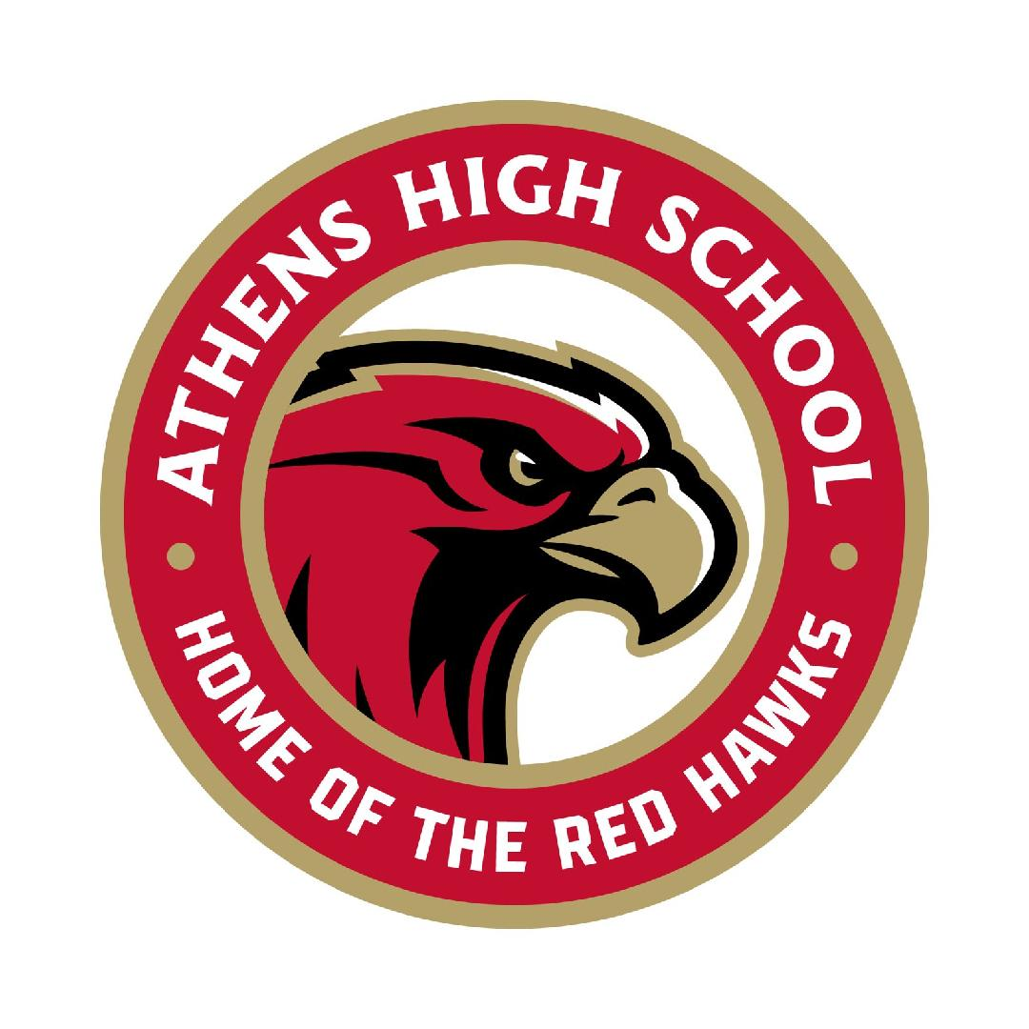

4333 John R Road, Troy, MI. 48085

Tax ID#: 32-0285534

Join us in celebrating the 2024 Graduates of Athens High School!

Dear Community Business Owner:

The Athens High School Senior All Night Party Planning Committee is proud to announce that it will again be hosting a Senior All Night Party June 1, 2024! The purpose of this party is to provide a safe and memorable, final group event for the Class of 2024.

You can join us in celebrating our graduates by donating to this FUN event in one of several ways!

- Sponsorship Opportunities – See attached list for all the details! Pick a sponsorship level, complete the form & email it back to us at athenssanp.chair@gmail.com Be sure to include a jpeg of your company logo.

- Monetary Donations:

Check: Payable to: Athens Senior All Night Party (please notate “donation”)

Zelle – Athenssanp.treas@gmail.com (please put in notes: “donation”)

Product Donations:

Gift Cards for prizes (i.e., Amazon, food/restaurant, stores, gas, etc.)

Tickets to Sporting Events / Experiences (rock climbing, ropes courses, etc.)

Dorm Room Necessities (bedding, throw blankets, body pillows, mini fridge, futon, Keurig, storage containers, desk lamp)

Electronics (TV, laptop, gaming systems, fitness tracker (Fitbit/Apple watch)
We cannot wait to showcase your donations on our social media channels & SANP website! Furthermore, we cannot do this without you and thank you for your continued support and generosity.

The Athen Senior All Night Party Committee is a public charity exempt from federal income tax under Internal Revenue Code Section 501(c)(3). Donors may deduct contributions made to the Athen Senior All Night Party Committee under Internal Revenue Code Section 170. Athens Senior All Night Party Committee is also qualified to receive tax deductible bequests, devises, transfers, or gifts under Section 2055, 2106, or 2522.

Please feel free to contact us if you would like us to pick up your donation or if you have any related questions or comments.
Foundation’s Federal Tax Identification number is 30-0622121.

Thank you in advance for your time and consideration.

Sincerely,

ATHENS HIGH SCHOOL SENIOR ALL NIGHT PARTY
Kristen Stachura
Chairperson
E-Mail: athenssanp.chair@gmail.com
2024 Athens High School Senior All Night Party Sponsorships

Pinnacle: $2,000 - Sponsor the Mechanical Bucking Bull, Palm Readers, or Hypnotist!

Sponsorship to include: Individual “Sponsored by” signage displayed at the Event you sponsor. Acknowledgement on scrolling Marquee sign outside of Athens High School (right on John R), shout-outs on all social media channels, & you can add your promo materials to the student gift bags.

Platinum: $1500! – Sit down Arcade Games or Inflatables!

Sponsorship to include: Individual “Sponsored by” signage displayed at the Event you sponsor. Acknowledgement on scrolling Marquee sign outside of Athens High School (right on John R), shout-outs on all social media channels, & you can add your promo materials to the student gift bags.

Diamond $1000 – Comedian, Casino, or Coffee Cart!

Sponsorship to include: Individual “Sponsored by” signage displayed at the Event you sponsor. Acknowledgement on scrolling Marquee sign outside of Athens High School (right on John R), shout-outs on all social media channels, & you can add your promo materials to the student gift bags.

Gold: $750 – Sponsor Food for the Evening!

Sponsorship to include: Individual “Sponsored by” signage displayed at the Event you sponsor. Acknowledgement on scrolling Marquee sign outside of Athens High School (right on John R), shout-outs on all social media channels, & you can add your promo materials to the student gift bags.

Silver: $500 – Sponsor Caricaturist!

Sponsorship to include: Individual “Sponsored by” signage displayed at the Event you sponsor. Acknowledgement on scrolling Marquee sign outside of Athens High School (right on John R), shout-outs on all social media channels, & you can add your promo materials to the student gift bags.

Bronze: $250 – Sponsor Donation Items!

Donations of gift cards, merchandise, event tickets, memorabilia, or other items that can be used in the raffle and other prize giveaways as well as food donations the night of the party valued at $250.

Sponsorship to include: Your business name/logo displayed on large banner displayed at party-check in point and you can add your promo materials to the student gift bags.
- Yes, we have promo materials to include in gift bags!
Yes, we’d love to support the Athens Class of 2024 and their Senior All Night Party!

Contact Name: ___________________________ Business Name: _____________________________
Address: ____________________________________________________________________________
Phone #: ____________________________ Email: _____________________________________
Web Address: ___________________________
*** Athens Senior All Night Party is a 501 (c)(3) non-profit organization. ***
Please keep this letter as receipt of your tax-deductible donation.

